1. [20 points] Which of the following statements about the circulation is the most correct? Briefly explain why each of the incorrect statements is, indeed, incorrect.
2. The pulse pressure in the inferior vena cava is larger than the pulse pressure in the renal artery.
3. The total cross-sectional area of all of the arterioles taken together is less than the cross-sectional area of all of the large arteries (taken together).
4. Blood flow velocity is less in the capillaries than it is in the superior vena cava.
5. Mean blood pressure in the large veins is about equal to mean blood pressure in the large arteries.
6. The pulse pressure in the inferior vena cava is larger than the pulse pressure in the renal artery.

This is not correct, if we look at the graph giving the variation in pressure (pulse pressure), velocity and cross-sectional area, and more specifically at the green curve, the pulse pressure in vena cava is close to zero compared to the pressure in arteries including renal artery (video 4, slide 3).

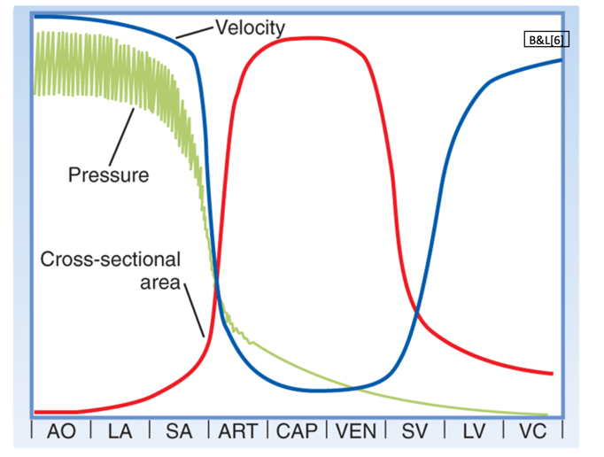

**Fig.1: Variation in pulse pressure, velocity and cross-sectional area through the circulatory system.**

1. The total cross-sectional area of all of the arterioles taken together is less than the cross-sectional area of all of the large arteries (taken together).

The cross-sectional area, of any part of the vasculature is taken as the sum of all the vessels at that level and not of a single vessel individually. As observed in figure 1, the total cross-sectional area for SA: small arteries (arterioles), is larger than the total cross-sectional area for LA: large arteries (see graph above).

1. Blood flow velocity is less in the capillaries than it is in the superior vena cava.
2. Mean blood pressure in the large veins is about equal to mean blood pressure in the large arteries.

Mean blood pressure, MBP, is approximately:

MBP = DP + 1/3 (SP – DP)

where:

DP: diastolic pressure

SP: systolic pressure

In figure 2, the diastolic pressures in the arteries, in systemic and pulmonary circulation, is much larger than the diastolic pressures in the large veins. The difference between systolic and diastolic pressure of the arteries is also larger compared to the difference for these pressures of the veins. Hence mean blood pressure in the large arteries is larger than the mean blood pressure in the large veins.

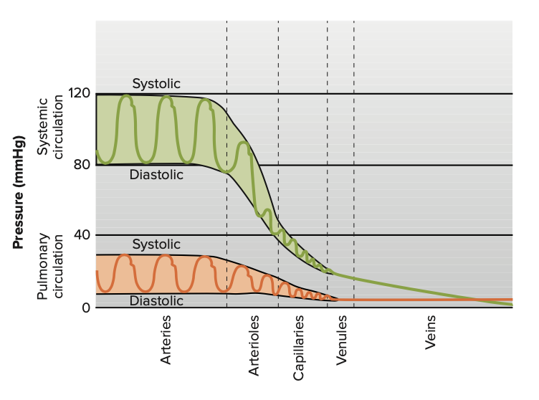

**Fig. 2: Pressures in the systemic and pulmonary vessels (VSL [15], Fig.12.32)**

1. [20 points] What are the physical characteristics/properties of blood and of blood vessels that affect blood flow through a blood vessel? Which of these characteristics/properties is under physiological control, and, if under control, in what (approximate) time frame? Briefly describe/discuss/explain the mechanism(s) of such control.

The principal determinant of resistance to blood flow is the vessel radius because resistance varies inversely as the fourth power of the radius. As shown in figure 3, resistance is highest in the capillaries and drops rapidly as the vessels increase in diameters. There are smooth muscles in the wall of the vessels, and contraction of these muscles, reduce the vessel radius which increases the resistance to blood flow and relaxation of these soft muscles increases vessel radius which reduce resistance. Another physical factor of blood vessel affecting blood flow, is its capacity to expand to accommodate surges in blood flow without increased resistance and it is referred as compliance.

Viscosity of the blood can also affect the blood flow. Because the blood behaves as a non-Newtonian fluid, the viscosity of the blood varies with shear rate. The viscosity of the blood diminishes as the shear rate increases (shear thinning, video 3, slide 3).

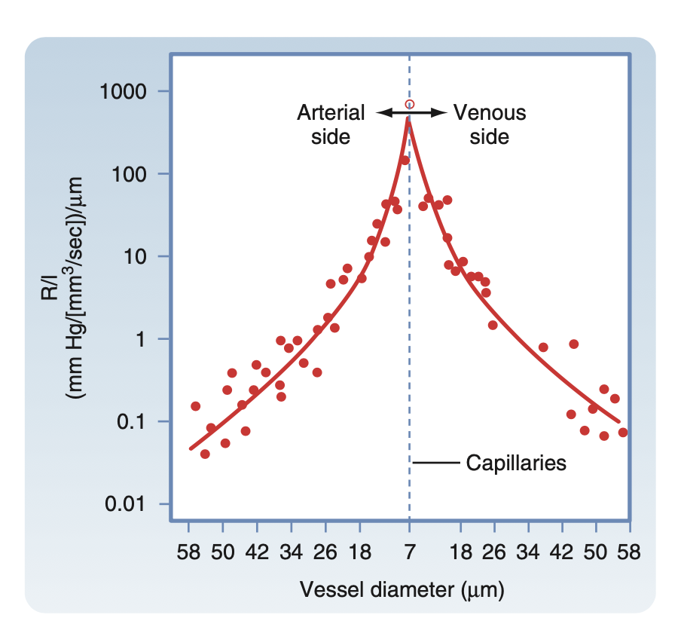

**Fig.3: B&L [7] Fig 17.4 resistance per Unit Length (R/l) of individual blood vessels**.

The mechanisms controlling vasoconstriction or vasodilation falls into two categories: local controls or reflex controls (which includes neural or hormonal controls) (VSL [15] Figure 12.39):

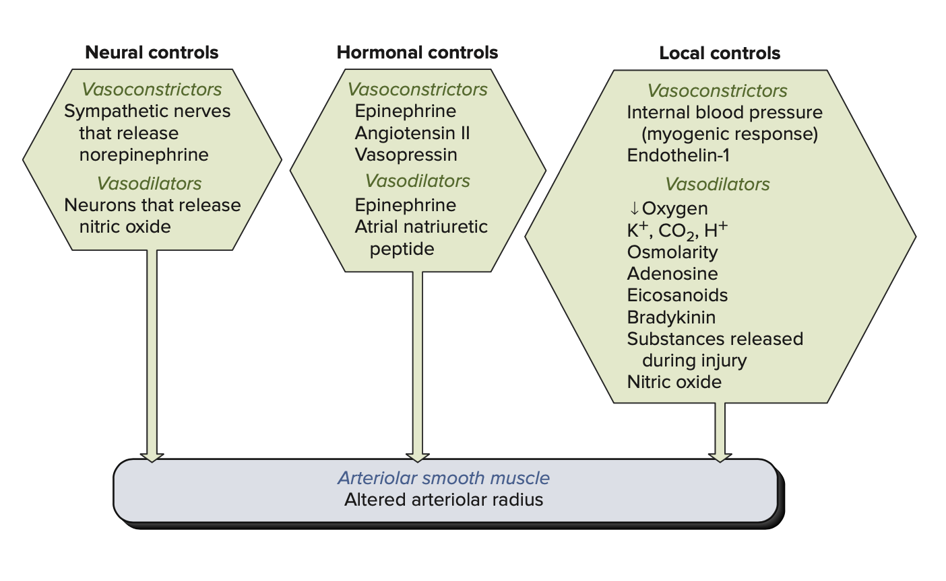

On average arteriolar radius control, which affects blood flow, and its response happens immediately (like shown in Fig. 14.3 in B&L [7] p 295). Following an abrupt increase or decrease of arterial blood pressure, blood flow returns towards control level within sub-minute or minutes (30 to 60 seconds, B&L [7] p 400).

1. [20 points] Distinguish between laminar flow and turbulent flow. Where in the circulation is turbulent flow likely to occur? Briefly explain why turbulent flow is likely to occur in those locations.

In laminar flow, as shown in figure 4, elements of the fluid move in streamlines parallel to the axis of the tube. There are no cross-currents perpendicular to the direction of flow, nor eddies or swirls of fluids. The highest velocity of the flow is in the center line and velocity at the wall is zero. In a turbulent flow, elements in the flow cross-over the center line, from layer to layer, vertices can develop which includes backward flows (eddies).

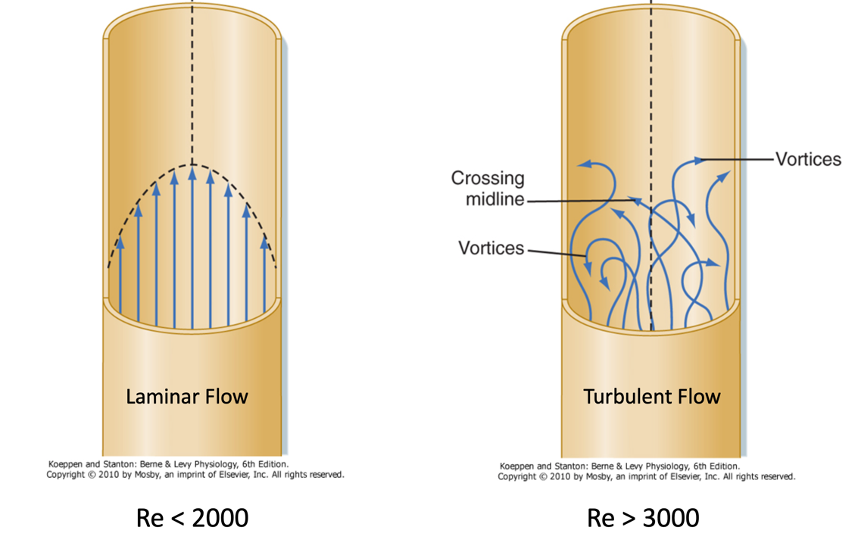

**Fig.4: Laminar and Turbulent Flow (Module 8 – Video 2 – Slide 4)**

Laminar flow occurs at lower velocities, below a threshold at which the flow becomes turbulent. The velocity is determined by the Reynolds number, which also depends on the viscosity and density of the fluid and diameter of the channel. A Reynold’s number less to 2000 usually characterizes a laminar flow, when this number is greater than 3000, the flow is turbulent. The Reynold’s number is (B&L [7] Equation 17.12):

where ρ: fluid density, D: tube diameter, v: mean velocity, : viscosity.

Reynold’s number indicates that a large diameter with rapid flow, where the density of the blood is high, tends towards turbulence (like the aorta). Also using Reynold’s number, we can see that high fluid densities, small vessel diameters or high flow velocities and low fluid viscosities can predispose to turbulences (B&L [7] p.349). In addition, any abnormal accumulation of material in the wall of vessel (diameter reduction) can cause flow turbulence (for ex. in atheroma, or in carotid artery disease)

1. [20 points] Which of the vessels in the circulation (aorta, artery ... vein, vena cavae) has the least connective tissue? Discuss/explain the physiological/ functional reason(s) for this.

Among all the vessels in the circulation, capillaries have the least connective tissue.

The capillaries, whose walls consist only of the thin endothelial layer of cells with an associated thin layer of connective tissue, allow rapid exchange of gases, water, and solutes with interstitial fluid. This exchange happens by three processes: diffusion, filtration and to a lesser extent pinocytosis. Small molecules, such as water, NaCl, urea, and, glucose, the thin layer of the capillary offers little restriction to diffusion, the only limitation to net movement across the capillary wall is the rate at which blood flow transports the molecules to the capillary (flow-limited) and they are efficiently transported on a short distance to parenchymal cells. O2 and CO2, also move rapidly through the capillary endothelium. Regarding the filtration process, in the presence of a hydrostatic pressure difference across it, the capillary wall behaves like a porous filter, some water passes through the capillary endothelial cell membranes, but most flows through apertures (pores) in the endothelial walls of the capillaries (B&L [7] p 363). The capillary wall acts as a selectively permeable membrane, which produces much greater restriction on the movements of large protein molecules.

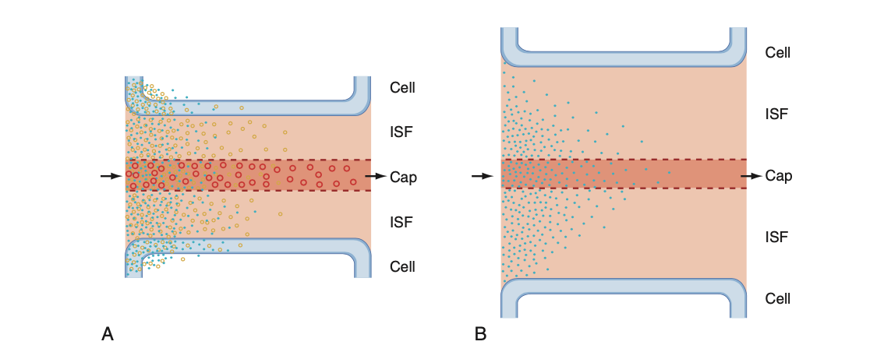

**Fig.5**: Flow- and Diffusion-Limited Transport from capillaries.

A: Flow-limited transport

B: Diffusion-limited transport. For more details refer to B&L [15] Fig. 17.25 p 362.